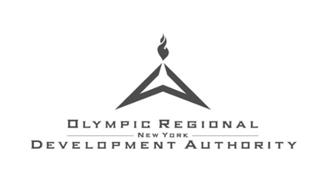
Darcy Rowe Norfolk, Director of Communications
dnorfolk@orda.org
518-302-5354

2022-2023 SKI3 Season Passes on Sale March 7
Ski and Ride this Spring for Free on Next Year’s Season Pass
Lake Placid, N.Y. (March 4, 2022) - The New York State Olympic Regional Development Authority (ORDA) announces that SKI3 Season Passes will go on sale on Monday, March 7, 2022. SKI3 Season Passes give skiers and riders access to Whiteface, Gore, and Belleayre resorts. The three resorts combined deliver more than 7,300 vertical feet of skiing, 882 acres of trails, 32 different glades, and over 250 total trails. Exciting facility improvements and upgrades have continued to improve the guest experience at each resort.
“Our season passholders are our most valued guests,” says Michael Pratt, ORDA CEO. “Over recent years, we’ve modernized our lodges, installed new lifts, expanded our snowmaking capabilities, and listened to our season passholders’ feedback for ways to enhance their experience at our resorts. We are excited for the 2022-2023 season and looking forward to preparing for another great year.”
Purchasing a Season Pass
Season Passes can most easily be purchased online and with the purchase of a 2022-2023 season pass, skiers and riders can use their pass starting March 7th through the rest of the 2021-2022 winter season. For pricing, product options, and purchasing options visit www.NYSKI3.com
100% SKI3 Assurance
Because life sometimes brings what can’t be anticipated, the SKI3 Pass comes with a 100% Assurance policy, giving passholders confidence in their purchase knowing that for any reason, they may request a full purchase credit (full details on SKI3 Assurance on each mountain’s specific website) for their 2022-23 season pass.
Special Renewal Rates for 2021-2022 Season Pass and Frequent Skier Card Holders
While new pass holders can enjoy skiing in the spring for free, ORDA offers returning passholders (and Frequent Skier Cardholders who wish to upgrade) a special renewal rate that can be easily accessed online.

Further mountain-specific details including season pass perks and terms and conditions:
Belleayre Mountain: https://www.belleayre.com/tickets/season-passes/
Gore Mountain: https://goremountain.com/season-passes/
Whiteface Mountain: https://whiteface.com/tickets-passes/season-passes/

ABOUT ORDA
Established in 1982, the New York State Olympic Regional Development Authority (ORDA) was created by the State of New York to manage the facilities used during the 1980 Olympic Winter Games at Lake Placid. ORDA operates Whiteface, Belleayre, and Gore Mountains, Mt. Van Hoevenberg, the James C. Sheffield Speed Skating Oval, the Olympic Jumping Complex, and the Olympic Center. As host to international and national championships, ORDA brings millions of athletes, spectators, and participants to the regions it serves, resulting in significant economic development.

